**ASSIGNMENT - 25.3**

**Problem Statement:**

1. Get a list of employees who receive a salary less than 100, compared to their immediate employee with higher salary in the same unit.
2. List of all employees who draw higher salary than the average salary of that department.

**Input:**

Use emp_details to solve queries.

Link:

<https://github.com/prateekATacadgild/DatasetsForCognizant/blob/master/emp_details.txt>

**Output:**

Creating table emp_salary in custom database and loading employee salary data into the table:

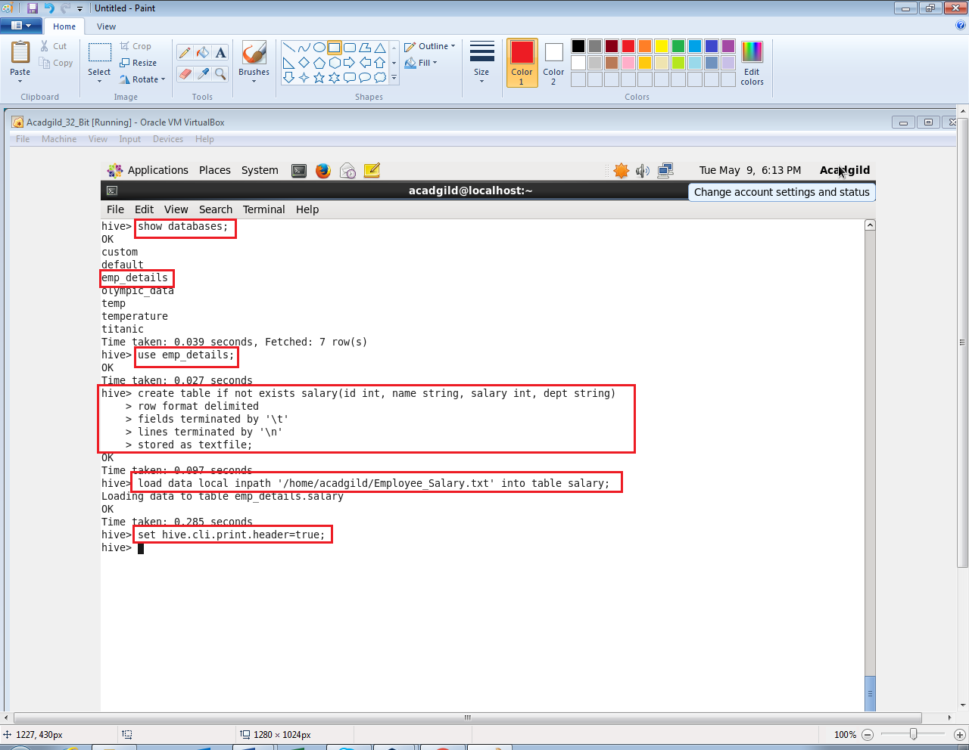

**Problem 1:**

Get a list of employees who receive a salary less than 100, compared to their immediate employee with higher salary in the same unit.

**Output 1:**

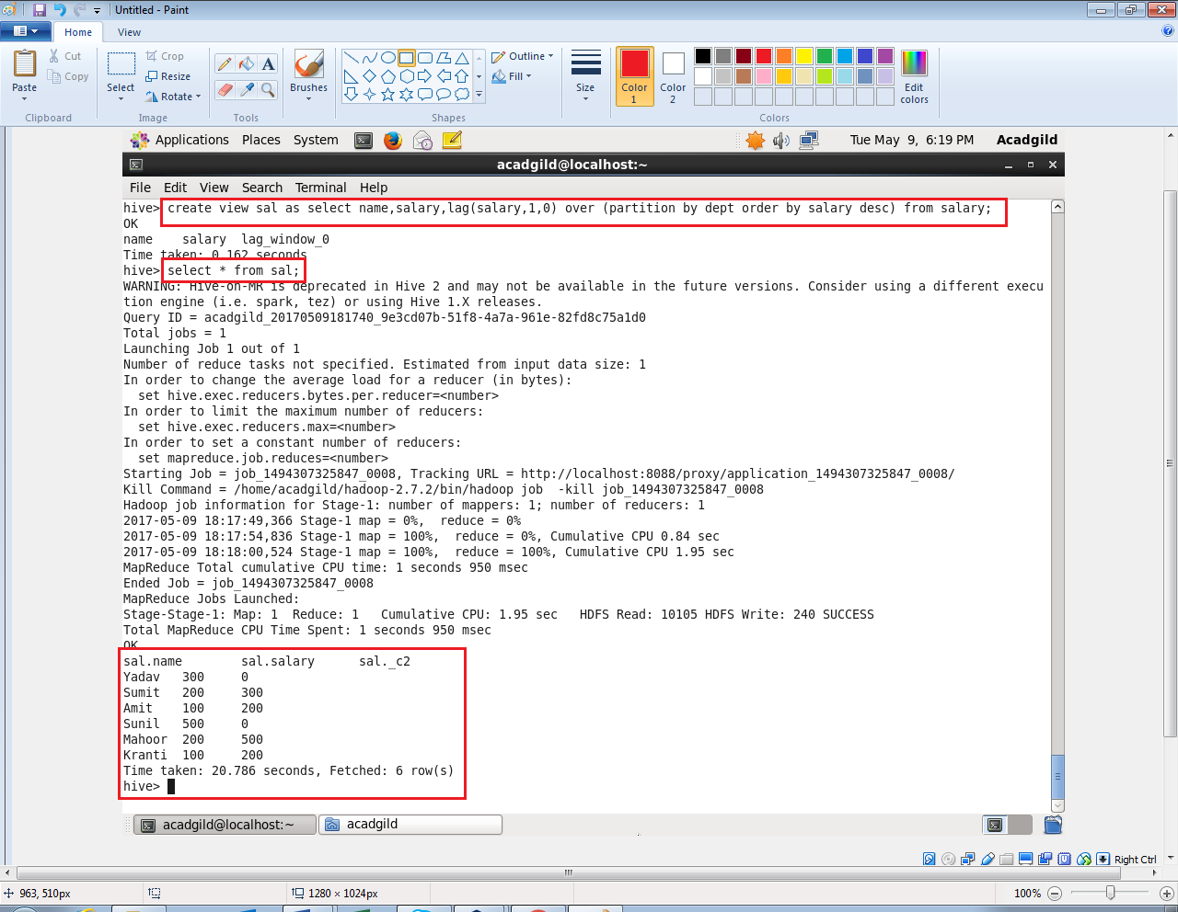

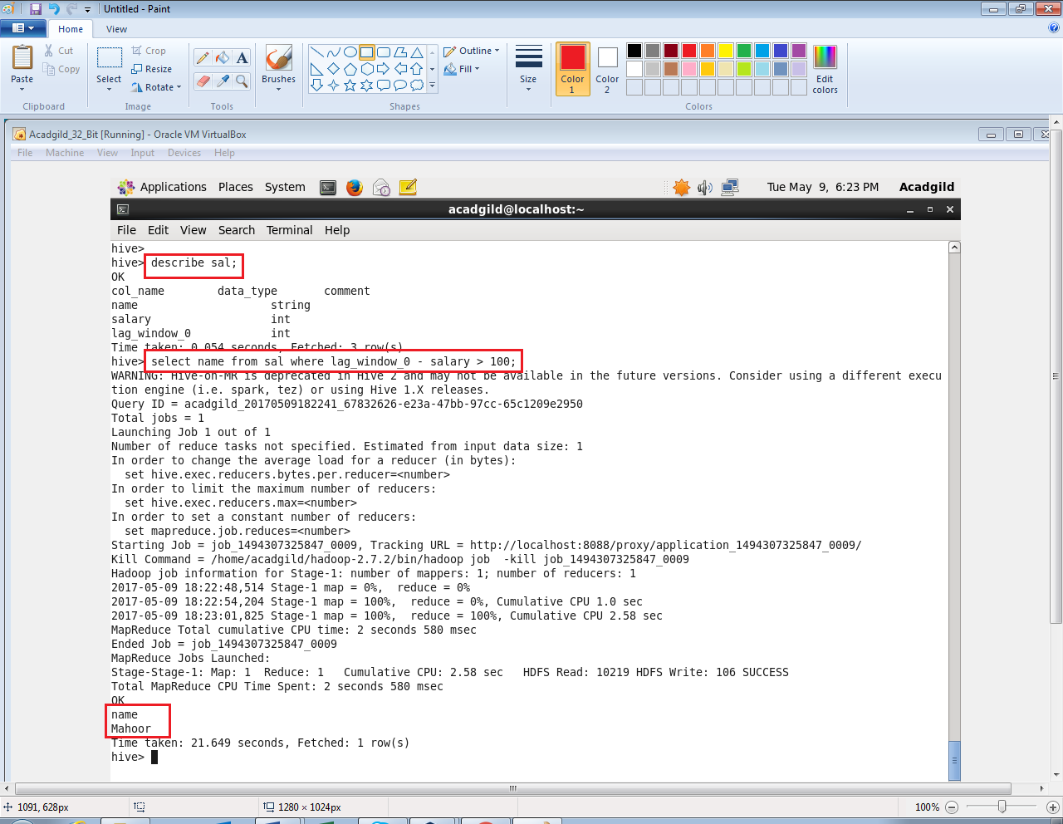

**Problem 2:**

List of all employees who draw higher salary than the average salary of that department.

**Output 2:**

